
full stack web development lab
Ms. Fiza Asmat

Hassan Shahid
241790
bscs 5c

Campus Workshop Registration Portal

TASK 1: Model Workshops and Registration State
Create a JavaScript module for at least three workshops (ID, name, fee, capacity, registered count). Show workshop cards and available spaces in the DOM using destructuring and template literals. Explain your module boundaries.

Output:
Workshop cards with available spaces
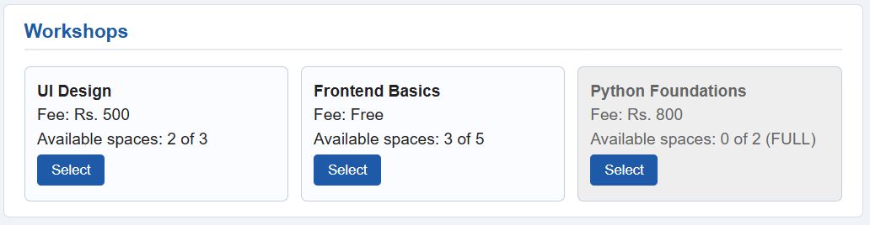

Answer:
Module boundaries: the code is split into files that each do one job. data.js holds the workshop data, the registrations and the shared rules (capacity check, reference number, recording a registration). selection.js holds only the selection logic. callbacks.js, promises.js and asyncawait.js each hold one style of the registration flow, using the same shared rules from data.js. app.js is the only file that touches the DOM: it draws the cards, handles clicks, shows the progress log and runs the demonstrations. index.html and style.css hold the layout and the styling.
Because the data and rules are separate from the page code, the three registration styles can be compared fairly. A registration is saved in only one place (onSuccess in app.js), after every stage has succeeded.

TASK 2: Build Interactive Selection with ES6
Allow a student to select one or more workshops within a limit. Use spread to build a new selection array and rest parameters in a function that accepts multiple workshop IDs. Show a live summary. Prevent duplicate IDs and invalid selections.

Output:
Live summary with selected workshops
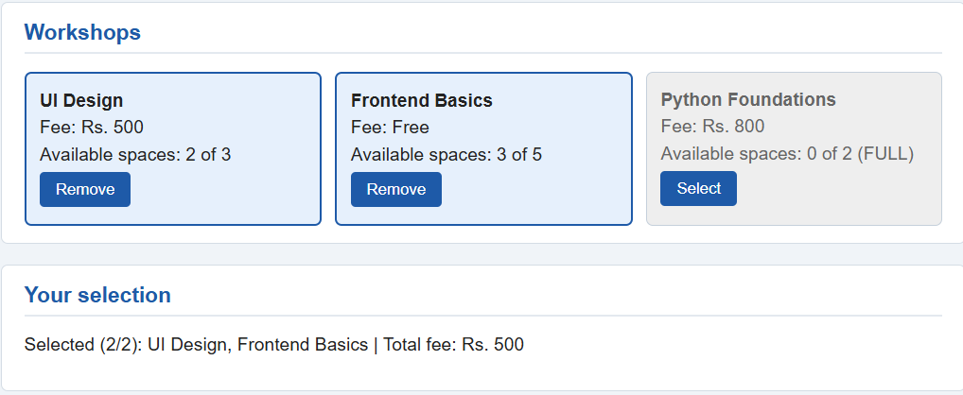
Duplicate / invalid selection rejected with a message
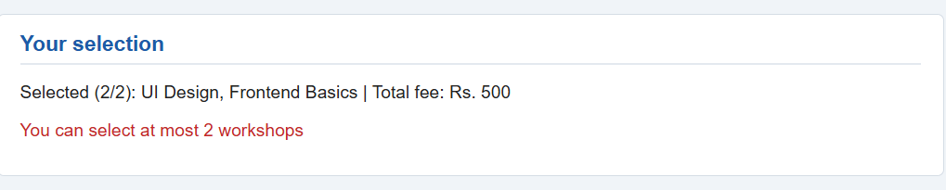

TASK 3: Implement an Error-First Callback
Simulate a delayed workshop-capacity check with setTimeout. Report success through callback(null, result) and failure through callback(error). Show a visible message for a full workshop and make sure approval does not start on failure.

Output:
Full workshop: visible error message and log showing approval never started
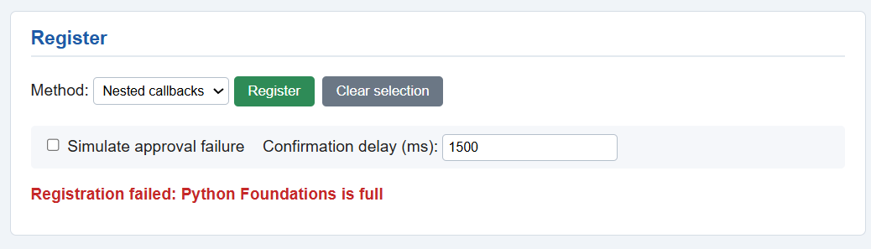

TASK 4: Add a Nested-Callback Registration Flow
Use dependent callback stages: check capacity, obtain simulated approval, generate a confirmation. Stop correctly on a failure at any stage. Add a visible progress log that shows the order of execution.

Output:
Successful registration: full progress log timeline
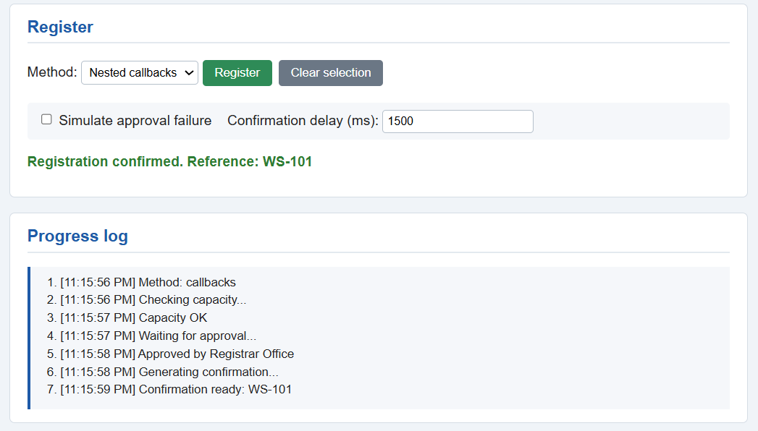
Failure at a stage: log stops at the failed stage
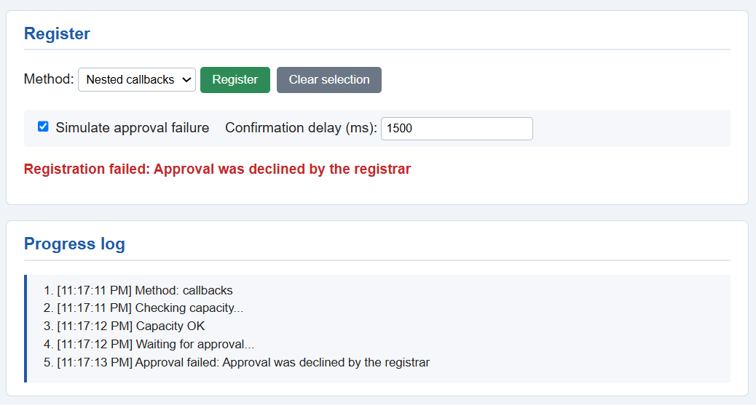

TASK 5: Rewrite with Promises and Async / Await
Create a Promise-based version of the same stages and a separate async/await version. Both must give equivalent results for success and failure. Use rejection handling and show an understandable error to the user.

Output:
Promise chain: success and failure
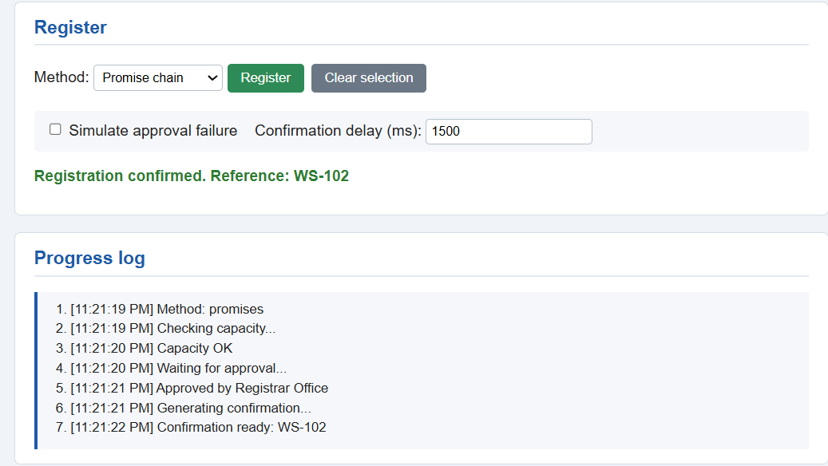
Async/await: success and failure
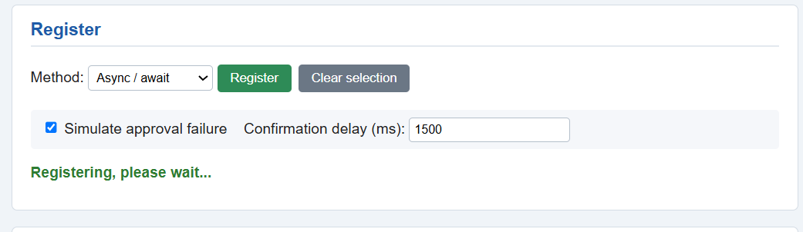

TASK 6: Test and Explain the System
Provide at least four demonstrations: successful registration, full workshop, simulated approval failure, and delayed confirmation. Do not record a confirmed registration on failed attempts. In a short reflection, compare nested callbacks, Promise chains and async/await, and identify which style you would use in a larger application.

Output:
Demo 1: successful registration
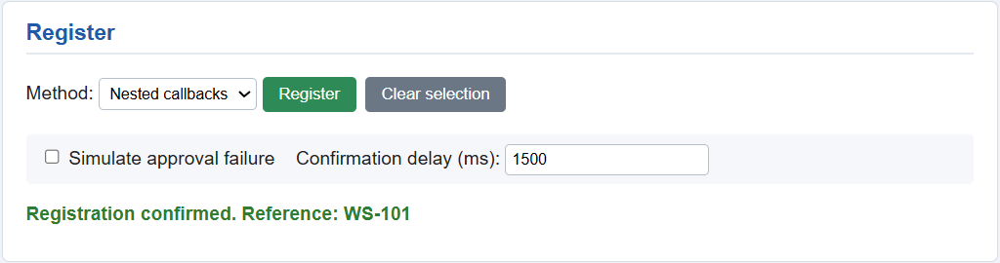
Demo 2: full workshop
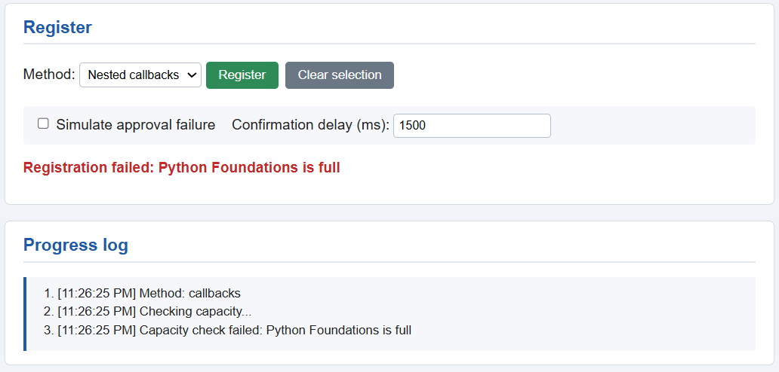
Demo 3: approval failure
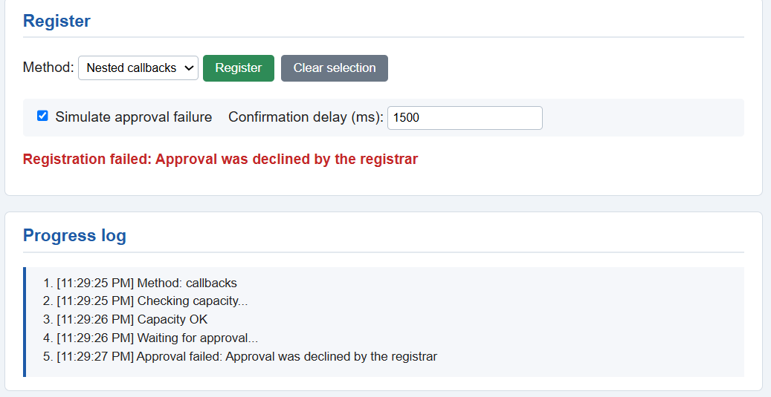
Demo 4: delayed confirmation
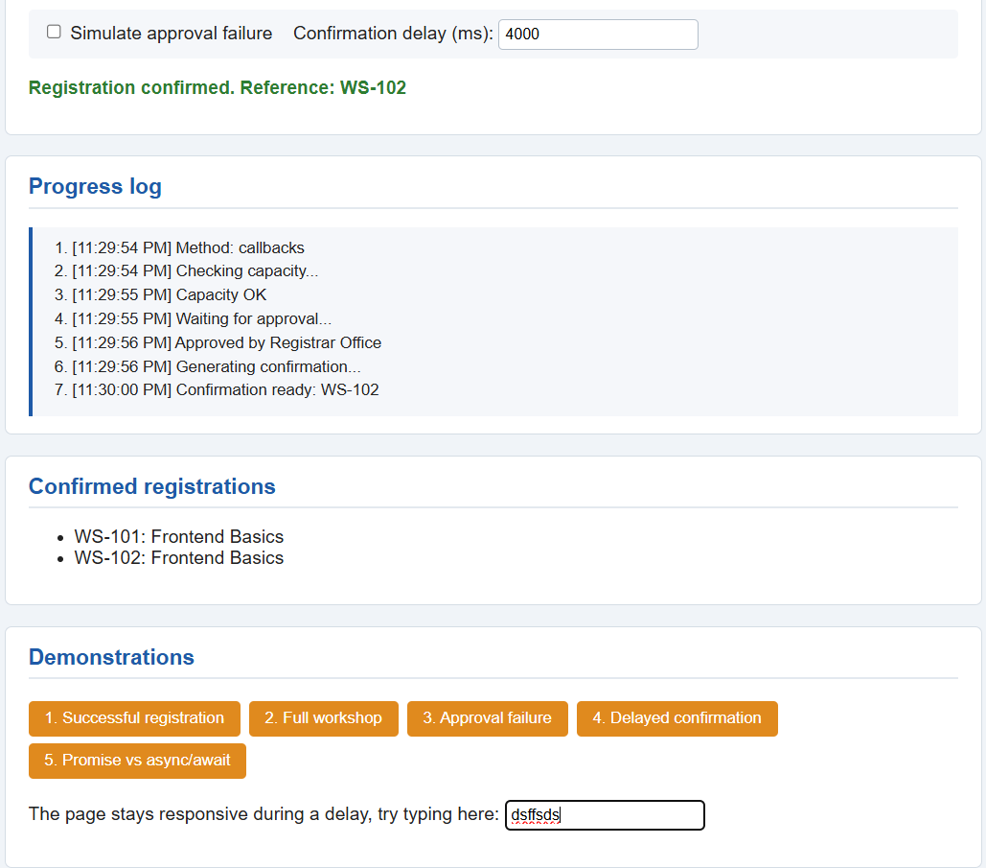

Testing log:
Scenario | Selected input | Expected result | Actual result
Available workshop | Frontend Basics, no failure | Progress completes, confirmation shown, available spaces decrease by 1 | All three stages ran in order. Confirmation WS-101 shown and the registration recorded.
Full workshop | Python Foundations | Rejected at capacity stage. No approval, no confirmation | “Python Foundations is full” shown. Stopped at the capacity check, with no approval or confirmation.
Approval failure | UI Design with approval failure ticked | Capacity passes, approval fails, no confirmation | Capacity passed. “Approval was declined by the registrar” shown, with no confirmation and nothing recorded.
Delayed confirmation | Frontend Basics, delay 4000 ms | Page stays responsive. Confirmation appears only after the delay | Confirmation appeared 4 seconds after “Generating confirmation...”. The page stayed usable.
Duplicate / invalid selection | Same workshop twice, unknown ID, or more than 2 workshops | Rejected with a message, no inconsistent state | Selecting a third workshop showed “You can select at most 2 workshops”. The selection was unchanged.
Promise vs async/await | Same inputs for both | Both reach the same final state | Both gave the same result in all three cases (fill in after running the comparison).

Reflection:
Nested callbacks work, but the code moves further to the right with every stage and the error check has to be repeated at each level. Promise chains are flatter and one .catch() handles every stage, but the .then() functions still make the flow harder to follow. Async/await reads like normal top-to-bottom code and try/catch is easy to understand.
In a larger application I would use async/await because it is the easiest to read, debug and extend with new stages.

Where each concept was used:
Template literals and destructuring: renderWorkshops() and renderSummary() in app.js.
Spread: addToSelection() in selection.js and totalFee(...selected) in app.js.
Rest parameters: addMany() and totalFee() in selection.js.
Error-first callbacks: checkCapacityCb, approvalCb and confirmationCb in callbacks.js.
Nested callbacks: registerWithCallbacks() in callbacks.js.
Promises and async/await: promises.js and registerWithAsync() in asyncawait.js.

